Student’s name | …………………………………………………….…… | Grade | 3
Subject | Computer | Week No. | 5
Lesson Title | Page Design | Unit
Worksheet No. ( 5 ) (Answer)
Question A: Write the correct name of each part.

Header | Footer
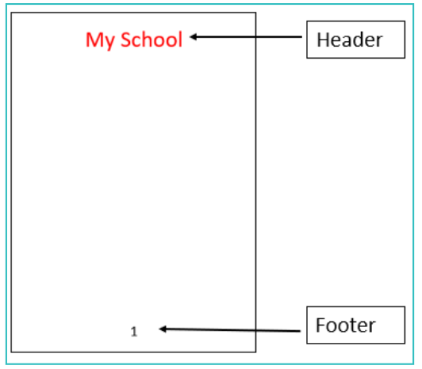
Footer
Header
Good Luck

